### Installation

1. **Environment Requirement**

pip install requirements

1. **Run the system on local machine**

Open terminal in our local fold file

$ git clone <https://github.com/A9gust/HotelRecommendationSystem.git>

$ cd HotelRecommendationSystem/backend

$ python app.py

$ cd HotelRecommendationSystem/hotel-recommendation

$ npm run serve

Go to URL using web browser <http://0.0.0.0:8080> or http://127.0.0.1:8080

### User Guide 1. Home Page

The Home Page provides a clear and intuitive interface, allowing users to explore the core functionalities of the hotel recommendation system. Upon entering the Home Page, users can click the “Signup for personalized recommendations!” button to be redirected to the sign-up and login page, where they can start customizing their personalized recommendation experience.

Scrolling down the page, the system presents a few highly-rated hotels selected based on overall user reviews. Users can click on any hotel name to view detailed information, including ratings, prices, and amenities.

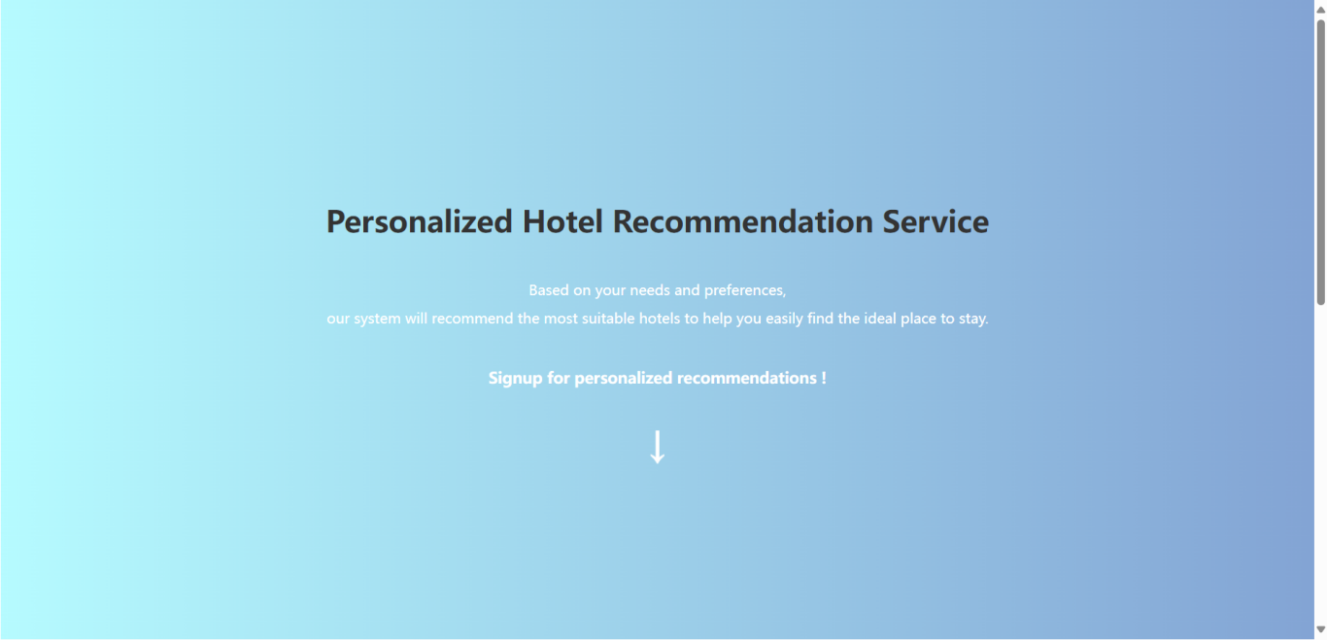

Figure 1: HomePage

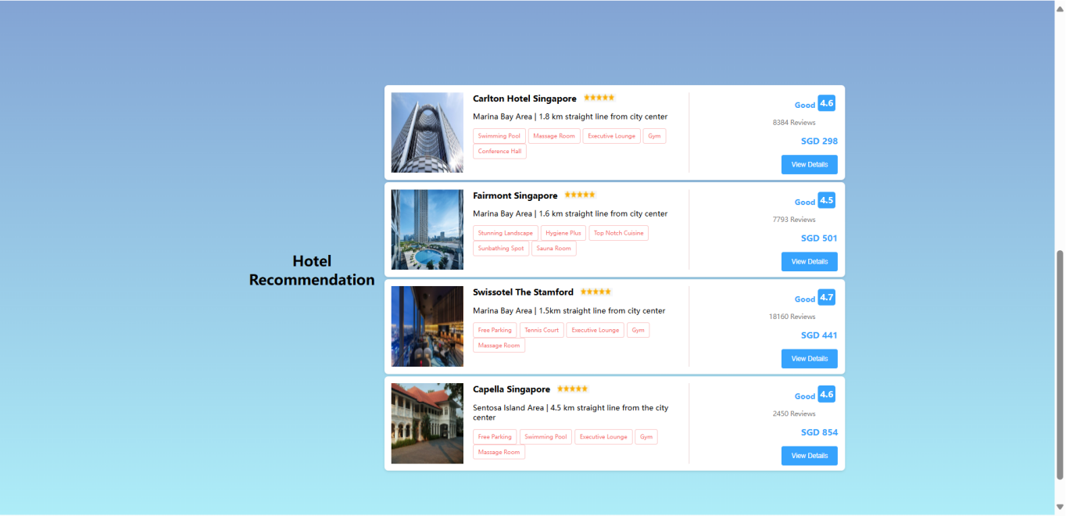

Figure 2: HomePage Recommendation

### 2. Sign-up and Login Page

On the Sign-up and Login Page, users are required to fill in personal details such as name, age, gender, address, country, holiday frequency per year, and whether they wish to become a member. This information helps the system tailor more personalized recommendations for each user.

Once all the information is entered, click “Submit” to complete the registration process.

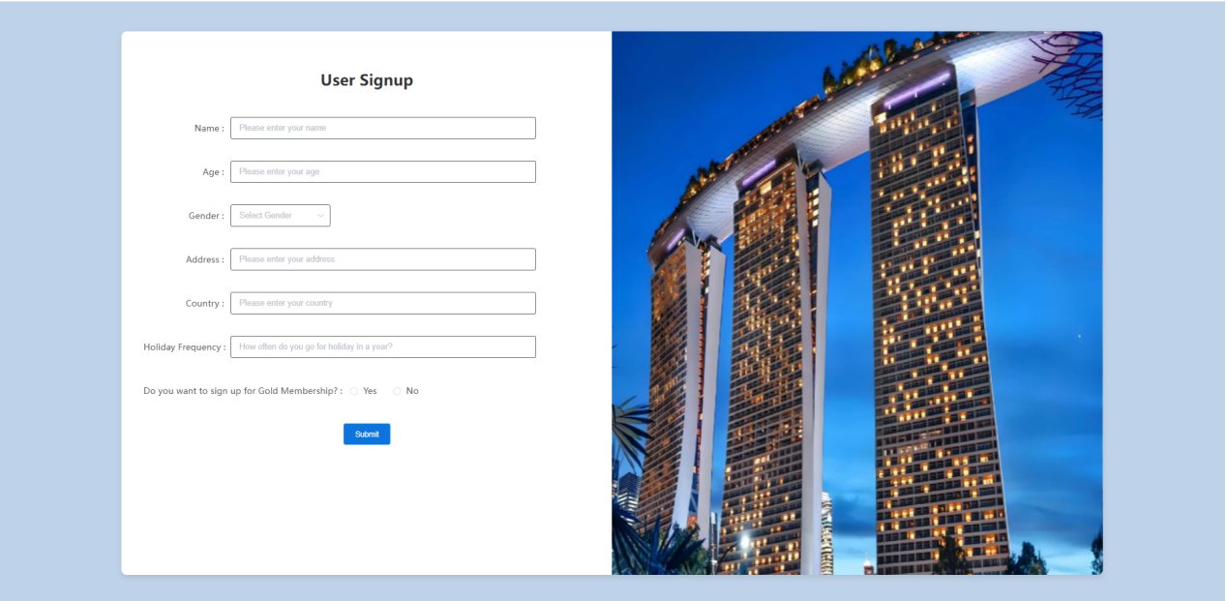

Figure 3: SignUp Page

### 3.Chat Recommendation Page

On the Chat Recommendation Page, users can input simple keywords or phrases to ask the system for hotel recommendations. For example, you can type “luxury hotel near the airport” or “budget hotel near the beach”, and the system will provide suggestions based on your query.

Additionally, users can use the quick-select buttons above the input box to quickly choose their preferences without typing, such as ”swimming pool”, “free parking” and “free breakfast”. After entering the request, click the “Send” button to confirm your input and click “Confirm” to proceed to the recommendation page.

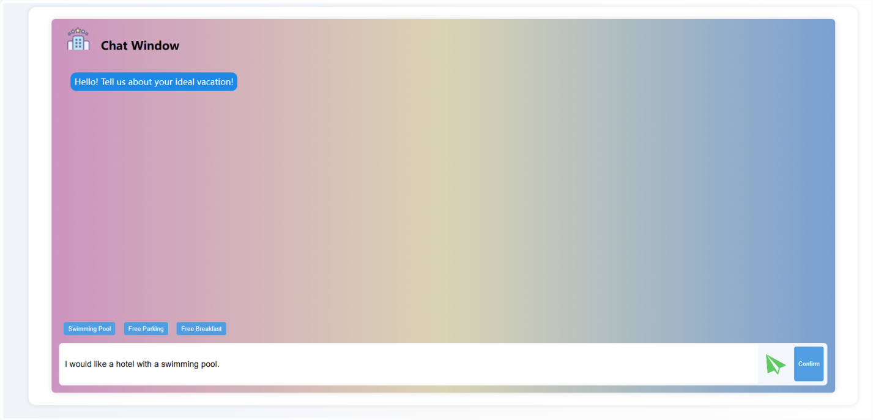

Figure 4: Chat Page

### 4. Preferences Selection Page

On the Preferences Selection Page, the system offers six hotel categories for users to choose from. Users can select one or more hotel types that they prefer by checking the boxes next to options like city hotel, beach resort, glamping, or mountain view. These preferences will help the system better understand user needs and provide more accurate recommendations.

After selecting your preferences, click the “Confirm Selection” button to submit your choices, and the system will generate personalized recommendations based on user’s selections.

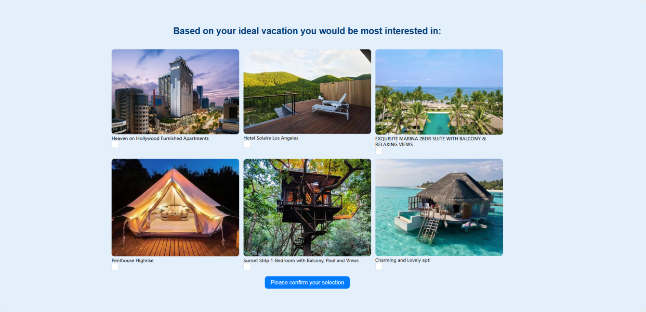

Figure 5: Preferences Selection Page

### 5.Rating Page

Based on the hotel types you selected on the previous page, the system will present several hotels that match your preferences. On this page, users are asked to rate each hotel on a scale of 1 to 5 stars. These ratings will help the system further refine its recommendations and improve the overall experience for future interactions.  
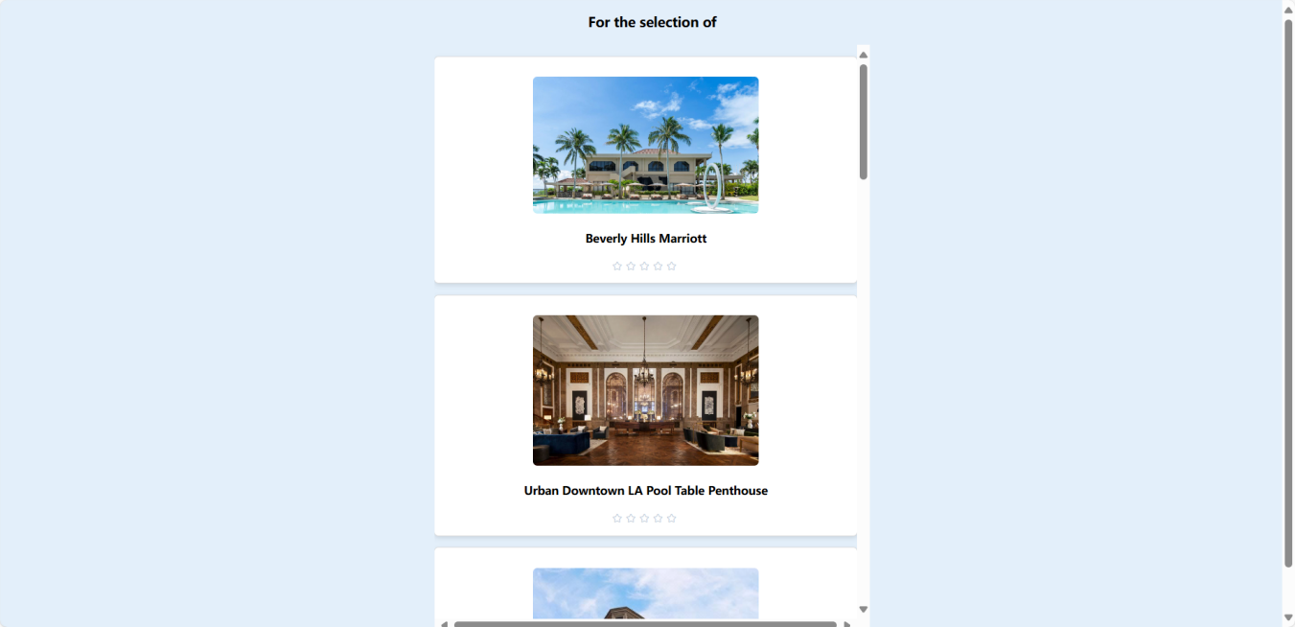

Figure 6: User Rating Page

### 6.Recommendation Results Page

This is the final recommendation results page, where the system provides a personalized list of hotels based on the user’s preferences, past behavior, and ratings. Each recommended hotel entry includes hotel images, name, rating, price, and other key details.

While the system is generating your recommendations, a loading screen will appear with the message: “Give us a moment, we are finding a suitable recommendation for you...”. Once the recommendations are ready, the results will be displayed.

Users can click on any hotel to view more detailed information and can proceed to book directly from this page. During the booking process, users can input their booking dates and number of guests, and by clicking the “Calculate Discount” button, the system will apply relevant business rules to calculate any available discounts (e.g., time-based promotional offers).

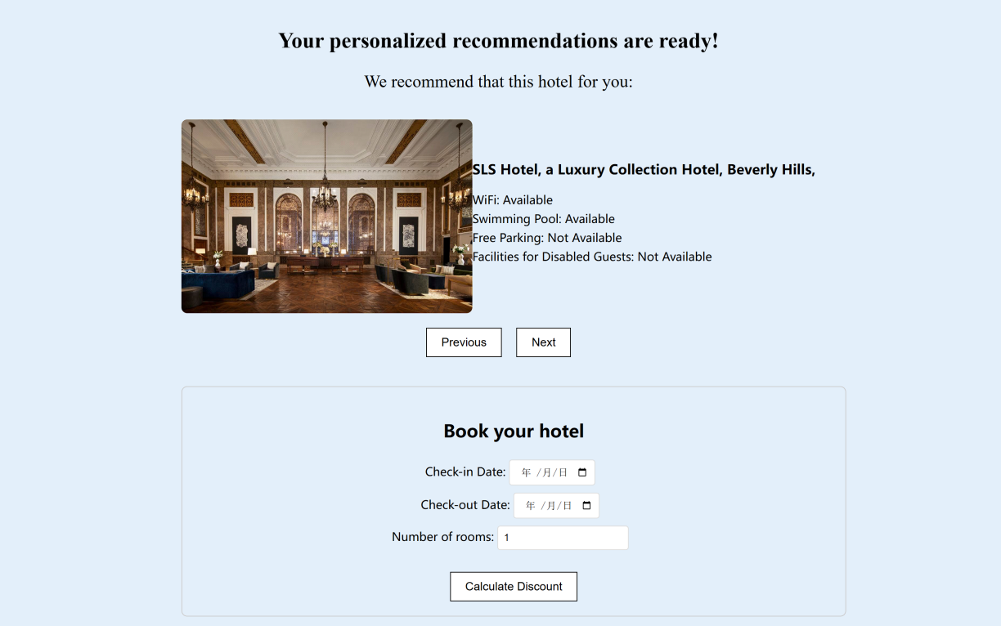

Figure 7: Result Page

### 7. System Rating Page

On the System Rating Page, users can rate the system based on the recommendation result and discount information we provided. The system will allow user to rate from 1 to 5, and a big thanks information will be shown to user after rating.

The page will collect the user rate to our recommendation result, which will help us to promote our system.

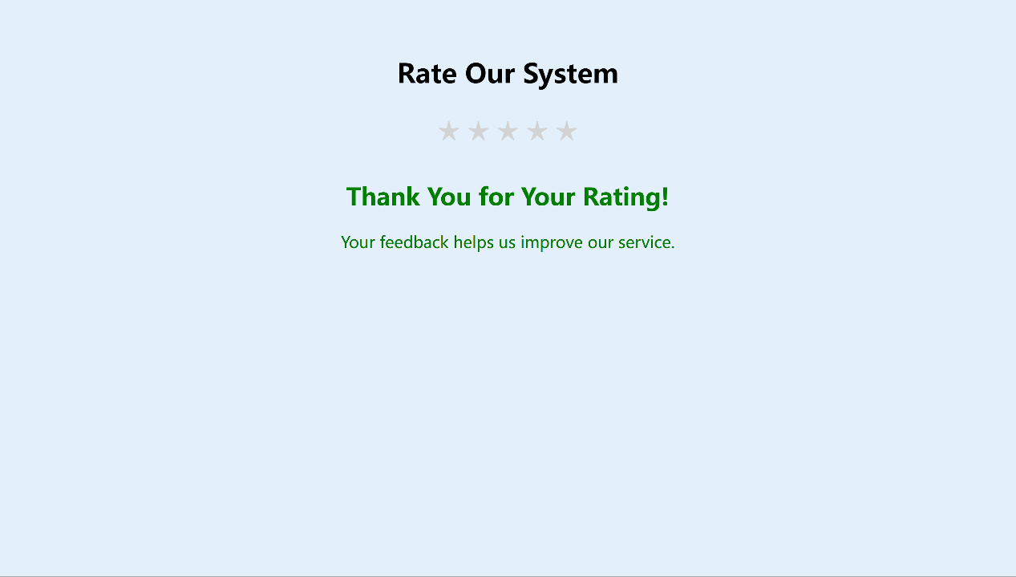

Figure 8: Rating System Page